We Care, We Respect, We Learn

Wimbish Primary Academy

*Behaviour Policy


Wimbish Primary Academy
*Behaviour Policy
Review frequency | Annually | Date of next review | Autumn 26
Committee | LGB | Required by Law | Yes

Required by law*

Behaviour Policy

“You can’t teach children to behave better by making them feel worse.
When children feel better, they behave better.”
Pam Leo

Aims and principles
As a school we define behaviour as everything a person says or does. The spectrum of behaviour ranges from extreme pro-social to extreme anti-social. It is our belief that our behaviour policy should increase pro-social behaviour and reduce anti-social behaviours through planned responses.

The aim of this policy is to set out the way in which we will support children to behave in a responsible, kind and sociable manner. It applies to all children and all adults in the school.

We will ensure that:
- all children and adults in the school have a clear understanding of the behaviour procedures
- the procedures are followed by everyone consistently and promptly
- children always understand the impact of their behaviour, positively or negatively, on others and why they are receiving a reward or consequence
- the adults in our school show children that they are valued, important and belong

These are our 3 Golden Rules that underpin this behaviour policy:
We:
- Respect – we are respectful, truthful and hard-working
- Care – we can show care to other people by ensuring that our behaviour does not negatively affect others and we form positive, compassionate relationships
- Learn – we learn from our experiences and use these to inform future choices and decisions

These expectations will be made explicit in the following ways:
- At the beginning of each term by the class teacher to their class
- In classrooms, through the display of our 3 Golden Rules
- Through assemblies
- Through daily interactions between adults and children
- In the school prospectus
- On the school website

How this policy supports the school’s vision

Our vision :

Wimbish Primary is a school where pupils, staff, families and the wider community are all welcomed and feel a sense of belonging. Our aim is for pupils to experience memorable learning through enriching provision, which includes and challenges all. By equipping pupils with skills and knowledge within a accessible, engaging and inspiring curriculum, our aspiration is for children to be independent and confident lifelong learners. At Wimbish Primary, our vision is to be successful, confident and responsible because we respect, we care and we learn.
This policy is based on current educational research, the Cambridgeshire Steps Therapeutic Approach to Policy, Positive Regard and Paul Dix’s work on behaviour management. Happy children are in the right frame of mind to learn and be challenged and are able to thrive. This policy enables the children to work in a safe and secure environment where all children and staff are valued.

Equality and inclusion statement
We will ensure that our practices and procedures are adapted to suit children and families with all protected characteristics. This will involve adapting practices to be appropriate for children with different cultures and educational, physical or emotional needs. Such adaptations will be made on a case-by-case basis in consultation with families and external professionals where necessary, and in the interests of the safety and wellbeing of all children. Wherever possible, we will take measures to pre-empt possible conflicts of interest, for example, by setting up individual behaviour plans and arranging additional staff training.

Prosocial behaviour
Prosocial behaviour is behaviour which is positive, caring, helpful and values social acceptance. We believe that prosocial behaviour needs to be taught and greatly valued.

Teaching Prosocial Behaviour
Long term behavioural change comes from developing internal discipline and an ability to self-regulate emotions. We believe that children learn how to make positive behaviour choices through;
• Positive relationships with adults and peers
- Positive role models, patterning and copying
- Positive phrasing and reminding
- Scripts and routines, repetition and structure
- Consistent, clear and agreed boundaries
- Praise, reward and positive reinforcement
- Comfort and forgiveness
- Providing children with the emotional language to discuss their feelings

Additional strategies for staff include:
- All staff to focus on the positive rather than the negative
- Be proactive when dealing with behaviour, rather than reactive.
- PIP and RIP - praise in public, reprimand in private to avoid public humiliation.
- Acknowledging children’s feelings
- Maintain regular scanning of the children under your responsibility - so you can see when they are off task or a situation is developing
- Be prepared - clear routines for transition. Have resources ready to reduce waiting times
- In the playground, staff on duty should position themselves appropriately on the playground or field, walking around the area, interacting with children, monitoring their behaviour and any developing situations. Staff must not stand together chatting. Children are less likely to misbehave if they know staff are vigilant.
- If a child approaches a member of staff to complain about the behaviour of another child, they must always be listened to and appropriate action must be taken. They must never be told to ignore the child who has upset them or to go away and play with someone else. Staff should support children in resolving disputes where possible, e.g. if a child reports that ‘Child X’ has been unkind to them, the child should be supported in telling ‘Child X’ how they are feeling and how things could be improved.

Praise, Reward and Celebration
Learners should develop the understanding that prosocial behaviour can be rewarding in itself and can also bring about positive experiences and feelings in others. When they are engaged and learning we need to ‘catch the children getting it right’ through specific praise. From building positive relationships with children, staff should know the manner in which children feel comfortable in receiving praise - be it through public acknowledgement or more privately. This can be done by:
- Praise and positive feedback from all adults and peers. This includes direct specific praise e.g. ‘Great listening Bob. Well done!’, indirect specific praise, e.g. ‘Mrs Bloggs, have you noticed how well Bob/this group is listening today?’, anonymous praise ‘There is a group who have worked brilliantly all morning. Fantastic work. That group has just earned the class a marble for our marble jar.’
- Children to be provided with stickers and be able to explain the reason they have been given the sticker
- Children given a special job or responsibility
- Praise Postcards written by staff and sent in the post to pupils for demonstrating specific prosocial behaviours.
- Rewarding of merits. Merits will be given for good work and attitude. A record of the merits earned by each child will be kept in the classroom on merit cards. Children will hand their merit card to the Headteacher if they reach the following milestones:- bronze, silver, gold and platinum. Completion of a merit card will result in the child receiving a sticker, certificate and a token for their colour team. The colour team whose members earn the most house points each term will win the colour cup.
- Sharing good work with other classes, teachers, Deputy Head or Head Teacher. Good work and achievements being displayed around the school, on the school website and on Twitter.
- Giving positive feedback to parents/carers at the end of the day or over the phone
- Marbles for whole class good conduct where pupils work together to earn a reward when the jar is full. A full jar equates to 50 marbles.
- Weekly Certificates and colour tokens are given to individual children by teachers and celebrated in celebration assembly.

We recognise that all of our children need recognition for their prosocial behaviour. Children who are always demonstrating prosocial behaviour should be noticed, as should those who are working hard to improve their behaviour and attitude. It is the responsibility of the class teacher to ensure that all of their children receive equal recognition for remembering the Golden Rules and for ‘over and above’ behaviour.

In this policy we are defining ‘reward’ as a desirable object or experience given to celebrate outcomes already achieved.

Supporting all learners to maintain prosocial behaviour

Some children will require differentiation or reasonable adjustments to enable them to maintain prosocial behaviour. These will be based on the needs of the children but may include:
- Arriving in class prior to the other children to have a quieter environment to enter
- Sitting in a specific space of their own or in a different way
- Being met and greeted on arrival by a member of staff
- Movement breaks
- Time to talk 1-2-1 with staff

Reminders and Redirection
Some children will require a reminder or redirection to maintain prosocial behaviour; the adult will select a strategy appropriate to the situation. These may include:
- Proximity praise – praising the children who are near to the child for their prosocial behaviour which encourages the child to copy their behaviour.
- Quiet, non-verbal reminder, e.g. a look or a sign, e.g. finger to lips to indicate non-talking time
- Quiet, verbal reminder using positive phrasing, e.g. ‘smart sitting… thank you’
- Quiet verbal reminder of the relevant rule or routine, e.g. ‘Remember our rule for safe scissors? … Thank you.’
- Quiet verbal reminder of a recent example of their prosocial behaviour.
- Moving the child to sit closer to an adult.
- An adult moving to sit closer to the child.
- An adult engaging with the child about their current activity/piece of work – identifying positive features, e.g. ‘Let’s look at what you’ve done so far…’

Anti-social behaviour
Anti-social behaviour is behaviour that causes harm to an individual, a group, to the community or to the environment.
Staff will initially use the strategies detailed above to encourage prosocial behaviour, however there will be times when children need additional support to learn about their anti-social behaviour through the use of consequences.

Consequences
At Wimbish Primary, consequences will be derived through logic and naturally follow an action. Children will experience consequences for their anti-social actions. We will use two types of consequences, ‘Protective’ and ‘Educational’. Both of these create a number of strategies within them to teach prosocial behaviours to our children, whilst keeping them in a safe learning environment. Certain anti-social behaviour incidents may not require a protective consequence but there must always be an educational consequence. Detailed below are some examples of the two types of consequences:

Protective consequences (removal of a freedom to manage risk of harm):
- Increased staff ratio e.g. specific supervision of a child in the playground
- Limited access to an area of the school
- Escorted in social situations e.g. to lunch
- Differentiated teaching space
- Exclusion

Educational consequences (this learning, rehearsing, or teaching is necessary to enable the child to move forward in a positive way)
- Completing tasks at a separate time in agreement with the child (with a staff member from their class or from SLT) to catch up on work they have not completed due to their behaviour choices – please note that the breaktime/lunchtime immediately following the antisocial behaviour may not be the most appropriate time for this to occur
- Rehearsing and re-planning responses to the event, for example, through the use of Social Stories where appropriate
- Assisting with repairs
- Educational opportunities e.g. research
- Whole class/Small group PSHE lessons on specific topics
- Restorative conversations and meetings
- Reflection Time: There may be exceptional situations where it may be necessary for learners to have a reflection time with a member of staff in order to complete the Reflect, Repair and Restore process (see below)

The majority of behaviours will be dealt with by the adults directly working with the children. There be occasions where an SLT member will support/intervene, agreeing appropriate consequences after considering the roots of the behaviour; the reflect, repair, restore process; whether the behaviour was a conscious or subconscious choice; the seriousness of the behaviour and any history of such behaviours. Appendix A details specific behaviours and responses, although is not an exhaustive list.
Adults’ responses to anti-social behaviours will aim to de-escalate the behaviour through one of or a combination of the following as appropriate:
- Positive phrasing with a “motivator” e.g - “Stand next to me, thank you” - “Put the toy on the table, thank you” - “Walk beside me”
- Limited choice e.g - “Put the pen on the table or in the box” - “When we are inside, lego or drawing” - “Talk to me here or in the courtyard”
- Disempowering the behaviour e.g. tactical ignoring - “You can listen from there” - “Come and find me when you come back” - “Come down in your own time”
- Use of a De-Escalation Script e.g - Use the person’s name, thank you name – “David” Acknowledge their right to their feelings – “I can see something is wrong” Tell them why you are there – “I am here to help” Offer help – “Talk to me and I will listen” Offer a “get-out” (positive phrasing) – “Come with me and…..”
- Physical intervention
There are situations when physical intervention may be necessary. Staff are trained by
Cambridgeshire Steps trainers in how to safely use physical intervention. Staff are instructed to be aware of the child’s age and individual circumstances when moving them as some children find this more upsetting than others. Situations may include:
- To comfort a student in distress, appropriate to their age and understanding.
- To support a child with their physical care (toileting, self-care, changing clothes).
- To gently direct a person.
- For activity reasons (drama, physical games).
- To avert danger to the child, other people or significant damage to property.

Reflect, repair and restore (after a crisis)
- Once the child is calm, relaxed and reflective, the experience can be re-visited with an adult.
- The adult will re-visit the experience by re-telling and exploring the incident with a changed set of feelings.
- The adult may ask the child questions to:
Explore what happened? (tell the story)
Explore what people were thinking and feeling at the time?
Explore who has been affected and how?
Explore how we can repair relationships?
Summarise what we have learnt so we are able to respond differently next time?

Personal Behaviour Plans
Pupils whose behaviour needs additional support may require a personal behaviour plan. These may be a ‘Predict and Prevent’ mini plan (see Appendix D) or if they place themselves and/or others at a risk of harm they will have individual risk reduction plans (see Appendix F) . These are overseen by the Headteacher, Deputy Headteacher and SENDCO to ensure that they are reviewed and updated in order to reflect changes and progress. Learners who require a risk reduction plan are those whose needs are exceptional and the usual everyday strategies and whole-school behaviour policy are not sufficient to meet these needs. This will include learners who may require some specific intervention to maintain their own and others’ safety and to ensure learning takes place for all.
A plan will:
- Be informed by a series of reflective documentation, following the Cambridgeshire STEPs recommended flow chart (see Appendix B)
- Be based on analysis of the child’s behaviour using the tools of subconscious or conscious behaviour analysis (see Appendix C), anxiety mapping (see Appendix D) and the roots and fruits proforma (see Appendix E). These will enable staff to establish the times/ places/ lessons that give the learner greater anxiety and triggers that could lead to difficult behaviours.
- Put in place risk reduction measures and differentiated measures that will lower the learners’ anxiety and enable the learner to show positive behaviours at school.
- Give clear de-escalation strategies and script that all adults can follow when speaking to the learner to lessen difficult and dangerous behaviours.

Recording, Reporting and Communication
Behaviour that is dealt with by SLT or frequently repeated behaviour causing concern should be recorded on Myconcern, marking the concern as a behavioural concern. Parents/carers should also be informed and a record of this meeting should be captured within the MyConcern log. See Appendix A for guidance.
Staff, including Lunchtime Supervisors must communicate playground behaviour issues with the children’s class teachers. All issues should be dealt with at the time and not left to class teachers to respond to after the event.
Information about behaviour could be shared with other professionals, e.g. SENDSS, Family workers after parental/carer consent is acquired.

Communication with Parents/carers
Parents/carers will be informed if ongoing poor behaviour affects the learning of the pupil themselves or their peers. They will also be informed if there is a breach of safety to others. This will be recorded on MyConcern. Appendix A should be used, alongside teacher judgement of when parents/carers must be informed and what consequences will/have been put in place. Discussions around future actions to support behaviour, for example seeking support from outside agencies, interventions or personal behaviour plans may also take place. Staff should not name other children involved. Conversations with parents/carers may be face to face, online using Zoom/Teams or on the telephone. Other parents/carers must not be within earshot.

SLT may inform parents/carers, in line with Appendix A, when they are dealing with behaviours that have required additional support. This may be alongside the class teachers. Conversations with parents/carers regarding behaviour are to be recorded on MyConcern. Class teachers will also ensure that at times they will give positive feedback to parents/carers at the end of the day or over the phone.

Exclusion
Serious incidents may result in a fixed term or permanent exclusion. These decisions are not made lightly and are informed by Local Authority and Anglian Learning guidance. Parents/carers are informed of the decision and reasons for the exclusion. A reintegration meeting is held with the parents/carers and child on their return to school. - Please see the exclusion policy

Bullying
Incidents of bullying or alleged bullying will be dealt with according to the anti-bullying policy.

Complaints
Parents/carers who have complaints about the way incidents are dealt with should be encouraged to use the complaints procedure.

Monitoring
Behaviour Management, including recording of incidents will be monitored and analysed by SLT and Governors.

Appendix A

We will always aim to proactively prevent antisocial behaviour through the use of positive behaviour strategies outlined in the policy. Responding to Anti-social Behaviour at Wimbish Primary may follow the below consequences:
Anti-social behaviour | Protective/Educational Consequence | Record Keeping
Low level, minor irregular off task behaviour e.g. chatting, calling out, wandering around classroom, tapping pencils, making faces and gestures | Class teacher discussion – teacher discretion to inform parents/carers.  Repeated low level/minor off task behaviour could result in the following:  - Reminder of behaviour “_____ class, desired behaviour, thank you” “X, desired behaviour, thank you” (e.g. Spider class, looking at the board now, thank you. Followed by “X, looking at the board now, thank you.” If desired behaviour not displayed.)  - RIP conversation, “X, I have spoken to you about Y behaviour _ times. If this behaviour continues, you will need to move to _.”  -Discrete conversation to move child to another place in the classroom  -Discrete conversation to move child to partner class/other area in school | None - unless the antisocial behaviour has become regular and daily for the child, in which case it will be logged onto MyConcern by a member of staff
Low level, minor friendship issue/verbal/physical incident | Class teacher discussion – teacher discretion to inform parents/carers  PSHE lessons could focus on issues arising in the class  Adult to facilitate a restorative conversation between children involved. | None - unless the antisocial behaviour has become regular and daily for the child, in which case it will be logged onto MyConcern by a member of staff
Child does not complete work in a lesson to expectation | The child will complete work with the class teacher at an agreed time. This may not be the next playtime/lunchtime if deemed this could escalate the situation, rather than de-escalate it. They could be asked to continue work when class is doing something else. If the work is still not meeting expectations, it may be sent home to be completed.  “X, is there any reason why you are finding it difficult to complete your work?” If no – “Your work target is ____. If you are choosing to not complete your work at this time, you will need to complete it at this time or this time” | None - unless the antisocial behaviour has become regular and daily for the child, in which case it will be logged onto MyConcern by a member of staff
Pupil not following adult instructions | Positive phrasing or Limited choice  Completion of tasks at another point (see above)  Teacher discretion to inform parents/carers, unless repeated. | None - unless the antisocial behaviour has become regular and daily for the child, or a safety concern, in which case it will be logged onto MyConcern by a member of staff
Unintentionally hurting someone’s feelings/or hurting someone physically/breaking something  e.g snapping a ruler whilst fiddling/playing with it but not in anger, | Reflection with class teacher- once the child is calm, relaxed and reflective, the experience can be re-visited with an adult.  - The adult will re-visit the experience by re-telling and exploring the incident with a changed set of feelings.  - The adult may ask the child questions to:  - Explore what happened? (tell the story)  - Explore what people were thinking and feeling at the time?  - Explore who has been affected and how?  - Explore how we can repair relationships?  - Summarise what we have learnt so we are able to respond differently next time? | Conversation with the child around appropriateness and consideration of people’s feelings.  If the teacher/TA is noting a recurrence of this kind of event (e.g. 3-4 times in a half term) this should be recorded on Myconcern.
Physical response in a game – e.g.  pushing, hacking, tripping on purpose (or believed to be on purpose) | Appropriate consequences may be as follows:  - Protective consequence - child to be redirected to an alternative activity for the remainder of the playtime to maintain safety for all pupils  - Educational consequence - research rules of the game or reflect on an alternative response for next time the situation occurs  - Restorative approach with others if needed discussion with other party involved, listening to feelings, reflecting on behaviours. | Record on MyConcern as a Behaviour event. by a member of staff
Not telling the truth | Discussion and reflection with class teacher on the importance of being honest | Conversation with pupil. If clear evidence of lying and still denial after proof (through adult witness or CCTV) then record on myconcern.
Taking property/food that does not belong to them | Reflection with class teacher – Parents/carers informed | Record on MyConcern as a Behaviour event by a member of staff.
Spoiling the work of a peer. | Repair the damage - e.g. rub out pencil marks, support the peer to fix any damage. Parents/carers informed at the discretion of the teacher  If reoccurring child will need to sit away from their peers | Conversation with pupil. If it occurs 3 x or more -pattern forming so inform SLT and record on MyConcern as a Behaviour event by a member of staff. If the child whose work has been spoilt appears to be targeted by the perpetrator then log as potential bullying or peer on peer
Refusing to go where asked or leaving the classroom without permission | Give clear choice (positive phrasing/limited choice) explain impact of child leaving the classroom without permission (e.g. safeguarding)  “X, an adult has asked you to _____. If you are choosing not to _____ at this time, you will need to _____ it at this time or this time”  Parents/carers informed | Record on MyConcern as a Behaviour event by a member of staff. SLT informed
Use of swearing or rude or aggressive language. | Use of de-escalation strategies and a conversation regarding the appropriateness of language and alternative words that could be used instead.  Parents/carers informed by teachers at their discretion (unless a regular occurrence, in which case parents should be notified). | Record on MyConcern as a Behaviour event.
Intentionally, through anger or as a result of heightened anxiety/stress inappropriate physical response or hurting a peer.  Breaking equipment, throwing objects to hurt someone, racism*, bullying*  Inform SLT | SLT will support the class teacher and may intervene, taking the lead in the situation.  To ensure all children feel happy and safe, structured play arrangements may be made; e.g. the child’s playtime is not taken with the class/whole school  Restorative conversation to repair damage and restore relationships. Also to reflect on more appropriate responses.  Educational consequences – e.g. learning about different cultures; explaining the value of equipment and the impact of the damage  Repair of equipment where possible  and appropriate  Social story to teach and rehearse alternative responses to situations  Possible internal exclusion with SLT  Parents/carers informed by class teacher or SLT | Record on MyConcern as a Behaviour event.  *In the case of perceived racist  comment then policy is followed  *In the case of perceived bullying then policy is followed.
Repeated incidents of intentionally, through anger or as a result of heightened anxiety/stress, inappropriate physical response or hurting a peer.  Use of swearing or rude or aggressive language.  Breaking equipment throwing objects to hurt someone, racism*, bullying*, refusing to go where asked or leaving the classroom without permission  Inform SLT | Parents/carers are informed and invited to meet with the class teacher/SLT.  Class teacher to follow the  Cambridgeshire Therapeutic Thinking “Behaviour flow chart” and complete Anxiety Mapping or Roots and Fruits with SLT/SENDCo Personal Behaviour Plan may be appropriate  Possible EHCP procedure  Possible internal exclusion with SLT  Possible Fixed term exclusion  Possible permanent exclusion may be considered  Involvement of outside agencies | Record on MyConcern as a Behaviour event.  *In the case of perceived racist  comment then policy is followed  *In the case of perceived bullying then policy is followed.  Appropriate Cambridgeshire Therapeutic Thinking documentation and analysis completed and uploaded as a document to the child’s MyConcern profile.

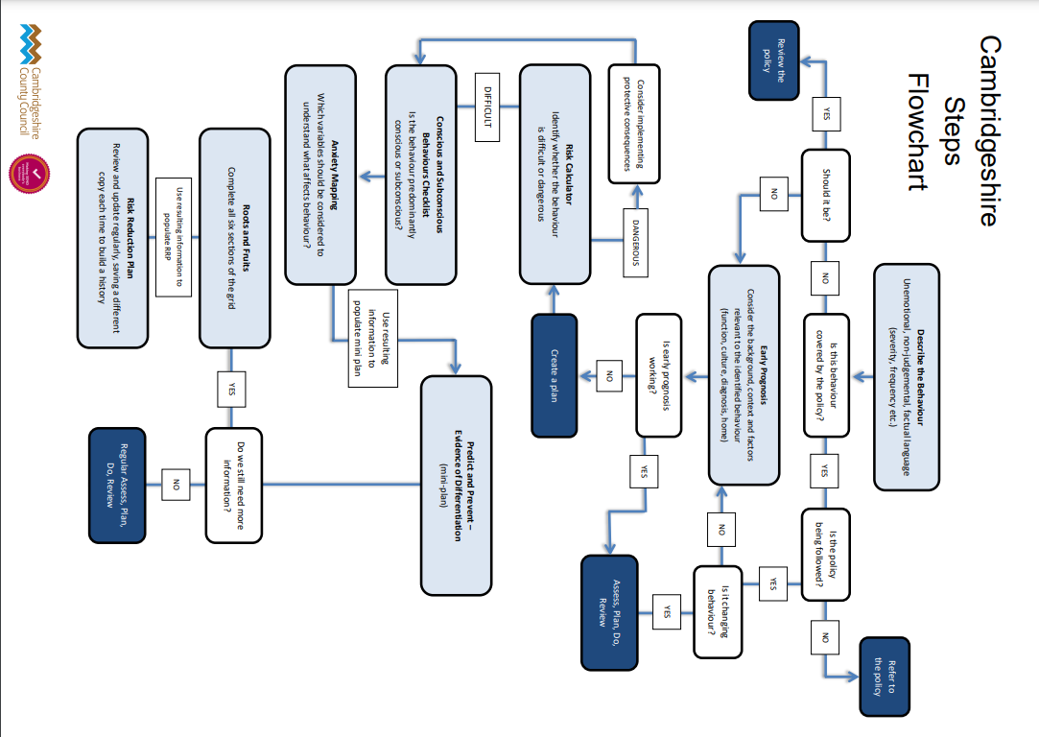
Appendix B

Appendix C
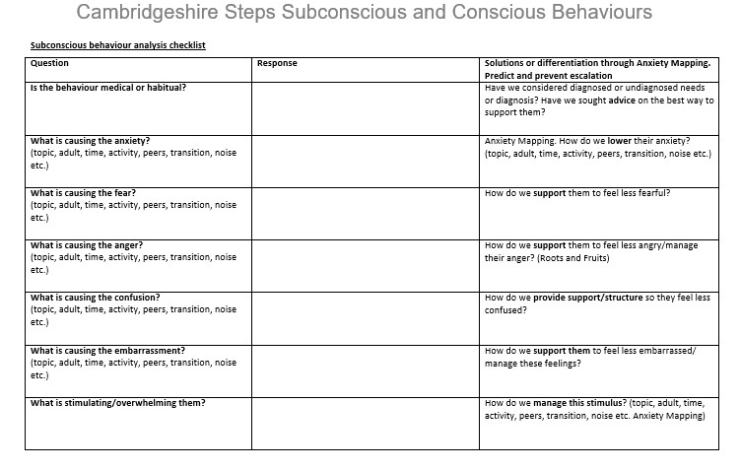
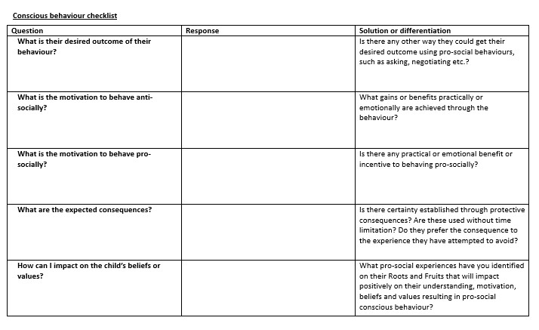

Appendix D
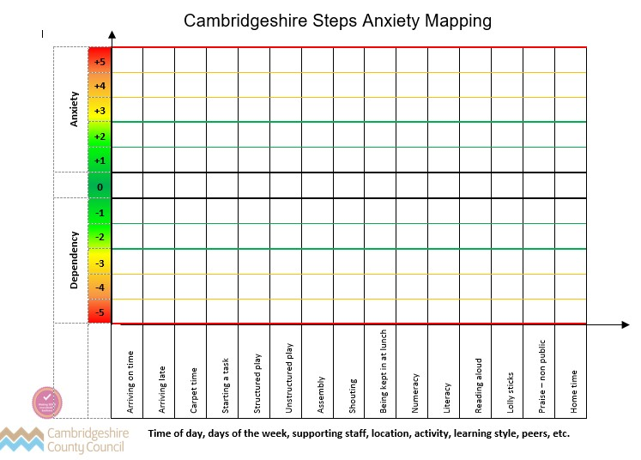
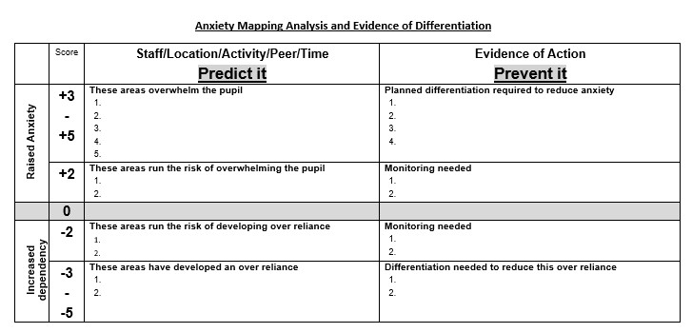

Appendix E
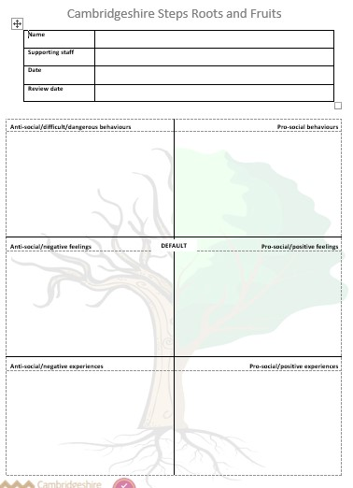

Appendix F
