**What is the Service Premium?**

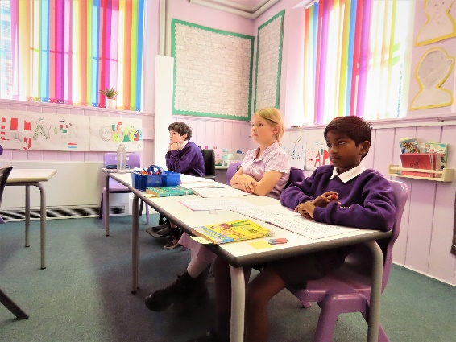The Department for Education (DfE) introduced the Service pupil premium (SPP) in April 2011 in recognition of the specific challenges children from Service families face and as part of the commitment to delivering the armed forces covenant.

State schools, academies and free schools in England, which have children of Service families in school years reception to year 11, can receive the SPP funding. It is designed to assist the school in providing the additional support that these children may need and is currently worth £340 per Service child who meets the eligibility criteria.

**How can my child receive the Service Premium?**

Pupils attract SPP if they meet one of the following criteria:

* 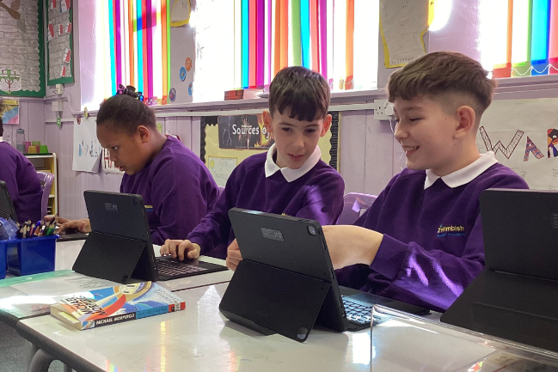one of their parents is serving in the regular armed forces (including pupils with a parent who is on full commitment as part of the full-time reserve service)
* they have been registered as a ‘Service child’ on a school census in the past six years
* one of their parents died whilst serving in the armed forces and the pupil receives a pension under the Armed Forces Compensation Scheme or the War Pensions Scheme
* one of their parents is in the armed forces of another nation and is stationed in England

**Children have to be flagged as Service children ahead of the autumn school census deadline. Service parents need to make the school aware of their status by talking to the school office. You will need to share your ID card with school so that we are able to update your child’s status.**

**How could my child be supported with this funding?**

The SPP is there for schools to provide mainly pastoral support for Service children, whereas the pupil premium (PP) was introduced to raise attainment and accelerate progress within disadvantaged groups.

Your child may be supported through:

* monitoring of service children’s progress compared to the wider school population to ensure that they learn, develop and achieve their own expected level of progress
* intervention strategies and support are put into place to support their learning
* the provision of a trained Teaching assistant to provide pastoral support and guidance for families
* Extra-curricular activities to enable service children to take part in certain activities that may not have been available to them due to the absence of one of their key adults. This has included workshops in school (such as Royal Institution science day and KS2 art workshop by local artist, Nadia Koo) and trips to the Fitzwilliam Museum and Boydell’s dairy farm.
* Forest school activities to provide a different experience: the children have really enjoyed being able to learn outdoors and this has provided great chances to develop children’s self-esteem and confidence. It also provides an outlet to provide emotional support for children who need it.
* Building strong links with the local barracks, engaging with community events and Army Welfare Services
* Wimbish passport – where children from military families may experience a higher level of mobility, we aim to gather as much information as possible about these pupils in order to support their transition into life at Wimbish. We use SPP to set up our “settling in” packs. This includes information for the children to understand where or what the key things are (teaching assistant names, where toilets are, etc) that they may be too concerned with to ask about. We use more of our SPP for providing teaching assistant support to provide intervention, booster and small groupwork when children join us with additional SEN. We move quickly in these situations as we never know how long we have until the child moves again, so it is imperative that we implement things quickly. This allows us to assess and sort out programmes and interventions fast.

Additional information is highlighted in the school’s Pupil Premium strategy document, found on the school website or can be requested from the school office.

