Pupil premium strategy statement – Wimbish Primary Academy
This statement details our school’s use of pupil premium (and recovery premium) funding to help improve the attainment of our disadvantaged pupils.
It outlines our pupil premium strategy, how we intend to spend the funding in this academic year and the outcomes for disadvantaged pupils last academic year.

School overview
Detail | Data
Number of pupils in school | 27
Proportion (%) of pupil premium eligible pupils | Pupil premium: 22% (6 pupils)  Service premium: 40% (11 pupils)  Overall pupils with funding: 62%
Academic year/years that our current pupil premium strategy plan covers (3 year plans are recommended – you must still publish an updated statement each academic year) | 2024 - 2027
Date this statement was published | November 2024
Date on which it will be reviewed | November 2025
Statement authorised by | Nichola Pickford
Pupil premium lead | Lizzie Beecroft-Sullivan
Governor / Trustee lead | Alison Weir/Dillon Mistry

Funding overview
Detail | Amount
Pupil premium funding allocation this academic year | £17,760
Pupil premium funding carried forward from previous years (enter £0 if not applicable) | £0
Total budget for this academic year  If your school is an academy in a trust that pools this funding, state the amount available to your school this academic year | £17,760

Part A: Pupil premium strategy plan

Statement of intent
Wimbish Primary Academy joined Anglian Learning on the 1st September 2023. The school was last inspected in May 2022 and was judged Good.
The school is close to the local Army Barracks and as such serves part of that community. The school has had a turbulent time over the past couple of years and pupil numbers have dropped significantly. There are currently 27 pupils on roll in November 2024. There were 48 pupils on roll in September 2023. In July 2022 there were 91.
Our 3 Golden Rules that sit alongside our values are
· We Respect
· We Care
· We Learn
Key foci for the 2023-2024 academic year were on establishing a learning culture within the school; establishing a therapeutic behaviour approach to ensure a calm, safe learning environment for all; to improve the quality of teaching and learning across the school; to develop a challenging, engaging and coherent curriculum; to develop an accurate understanding of pupil disadvantage in the school (e.g. a current and accurate SEND/PP/Service register) and begin to develop provision to support these areas of challenge
Long term foci:
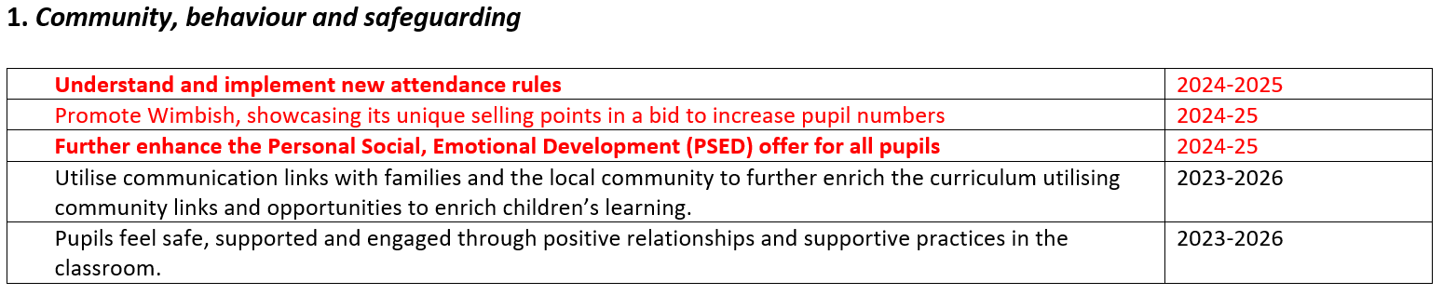
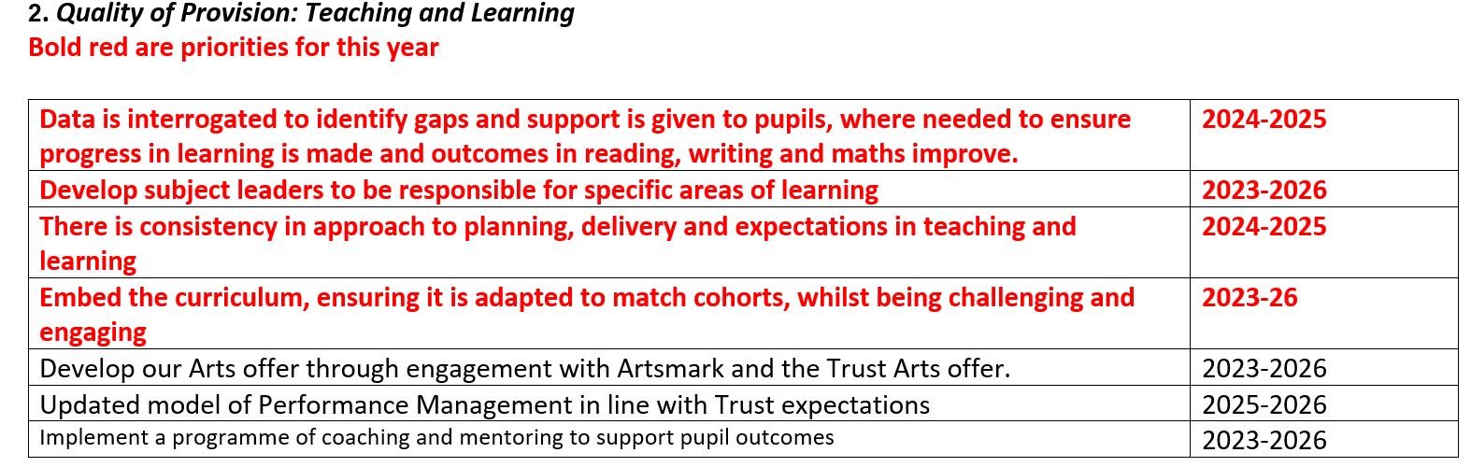
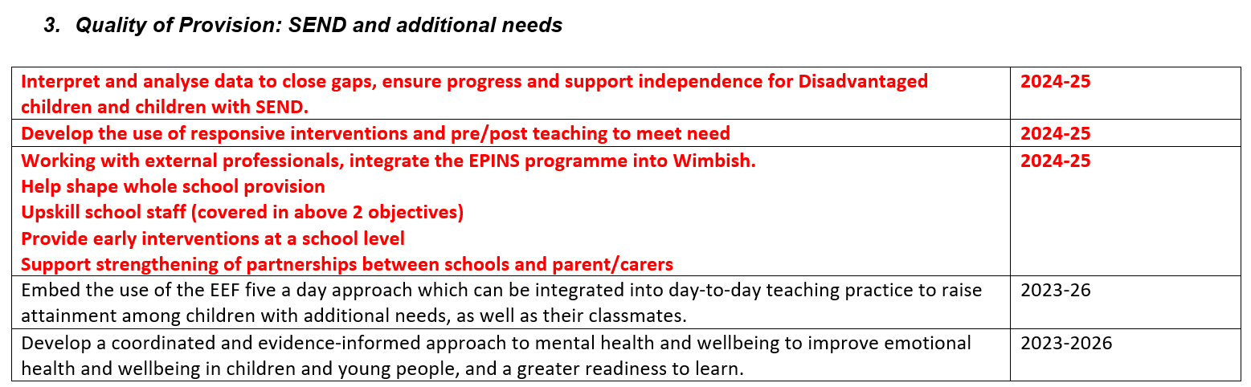

Challenges
This details the key challenges to achievement that we have identified among our disadvantaged pupils.

Challenge number | Detail of challenge
1 | School has academized (September 2023) with entirely new leadership and teaching staff; partial consistency within support staff
2 | Some children’s behaviour for learning shows that they are not yet ready to engage fully with curriculum
3 | Record keeping and accuracy of pupil premium register prior to academisation
4 | Tracking of academic attainment prior to academisation
5 | Academic outcomes and teaching/learning prior to academisation
6 | Engagement of some parents/carers is inconsistent

Intended outcomes
This explains the outcomes we are aiming for by the end of our current strategy plan, and how we will measure whether they have been achieved.
Intended outcome | Success criteria
Ensure there is an accurate register of children entitled to PP or Service Premium  Ensure that there is a clear strategy for support of children in receipt of Pupil Premium and Service Premium funding | PP register and service premium register will be accurate and representative of the school population  PP strategy will be published annually  Service premium FAQ sheet to be published and shared on Barracks and with school promotional materials
Implement a consistent, effective and therapeutic behaviour approach to ensure learning for all through the training of all staff in Therapeutic Thinking. | - Staff will receive training on therapeutic behaviour approach (December 2023) with top-ups planned across year; new staff receive training on therapeutic beahviour approach when hired  - Consistency in behaviour management will be evident across the school  - Consistent classroom routines and effective classroom management are established.  - Behaviour expectations are consistent across the whole school  - Stakeholders are confident in the implementation of the school’s behaviour policy  - Where pupils need additional support, individualised behaviour plans are established and reviewed  - Where pupils require additional support, external services are engaged with and targeted interventions are delivered in a response-to-need model
There is consistency in approach to planning, delivery and expectations in teaching and learning | Staff are trained in delivery of the curriculum and supported through regular developmental work; Training on use of The Write Stuff in English (Jane Considine) across the whole school (November 2023)  Use assessment schedule (see assessment timetable) to include reading, writing, mathematics, foundation subjects, GL NGRT, NGST and Progress Tests  High quality, targeted interventions are in place to support closing the gaps and identified barriers  Interventions are informed by interrogation and analysis of quantitative data, gained through class based and specialised assessments
Data is interrogated to identify gaps and support is given to pupils, where needed to ensure progress in learning is made and outcomes in reading, writing and maths improve. | Use assessment schedule (see assessment timetable) to include reading, writing, mathematics, foundation subjects, GL NGRT, NGST and Progress Tests  Pupil progress meetings are held to enable teachers and leaders to ensure support is directed and targeted at the point of need  Trained staff utilise specialised assessments in order to identify where pupils have additional needs or barriers to learning
Improve communication and engagement with parents to ensure all parents feel valued, supported as part of the school community and engaged in supporting their children’s learning and wellbeing. | Develop effective community links.  - work with Army Welfare Officer on Barracks  Attend Army Community groups/coffee mornings; Army community events  Effective working relationships are established and grown with parents/ carers  Parents/carers engage with school community events and outreach; e.g. science visits, coffee mornings, school events

Activity in this academic year
This details how we intend to spend our pupil premium (and recovery premium) funding this academic year to address the challenges listed above.

Teaching (for example, CPD, recruitment and retention)
Activity | Evidence that supports this approach | Challenge number(s) addressed
Developmental work delivered to support high quality teaching across the school (DHT and SENCO)  DHT / developmental work time - around 2hrs per week * average teacher hourly wage with on-costs £44.20 * 38 weeks in school = £3359.20 | https://www.tandfonline.com/doi/abs/10.1080/19415257.2018.1529611 | 1, 4, 5

Targeted academic support (for example, tutoring, one-to-one support, structured interventions)

Activity | Evidence that supports this approach | Challenge number(s) addressed
GL Assessment battery (NGRT, NGST, GL Progress Tests for English and Maths) to be completed across the school  Budget £2000 | https://committees.parliament.uk/writtenevidence/45954/html/ | 1, 3, 4 , 5
Specialised assessments to be completed for pupils whose standardised assessments highlight specific need (e.g. YARC, Sandwell, PhAB)  Budget £500 | https://committees.parliament.uk/writtenevidence/45954/html/ | 1, 3, 4 , 5
To identify pupils in pupil progress meetings who may need additional intervention and to plan provision/intervention to meet that need. This has been estimated to be as follows:  TA time - around 15hrs p/wk * average TA hourly wage pay £13.25 * 38 weeks in school  £7552.50 | https://educationendowmentfoundation.org.uk/courses/making-best-use-of-teaching-assistants-online-course/structured-interventions/recommendations-5-and-6-unpacking-the-evidence | 1, 3, 4 , 5

Wider strategies (for example, related to attendance, behaviour, wellbeing)

Activity | Evidence that supports this approach | Challenge number(s) addressed
Develop support for disadvantaged pupils with additional SEMH or pastoral needs by engaging with mental health CPD; provide high-quality resilience interventions; liaise with external agencies (e.g EP service, CAMHS, Health Visitor/School Nurse);  TA time - around 2hrs p/wk * average TA hourly wage pay £13.25 * 38 weeks in school = £1007  SENCo/referral time - around 2hrs per week * average teacher hourly wage £44.20 * 38 weeks in school = £3359.20 | https://d2tic4wvo1iusb.cloudfront.net/production/documents/guidance-for-teachers/pupil-premium/Pupil-Premium-resource-evidence-brief.pdf?v=1695997833
Increase profile of school and develop relationships with families and wider communities through frequent “Meet SLT” dropins; welcome events, subject specific cafes  Dropins half termly average teacher hourly wage with on-costs £44.20 *12hrs * 2members staff  £1060.80 | https://educationendowmentfoundation.org.uk/education-evidence/teaching-learning-toolkit/parental-engagement | 1, 6

Total budgeted cost: £18,838.70

Part B: Review of the previous academic year

Outcomes for disadvantaged pupils
Due to the incredibly small numbers of pupils in receipt of PPG in specific cohorts, data is not publicly reported to avoid identifying individual children. Data is available for Ofsted, school leaders and Governors.
Outcomes to be identified against new strategy in following years; interim strategy reviewed below:
Intended outcome | Comment
Ensure there is an accurate register of children entitled to PP or Service Premium | Staff worked hard to identify pupils who were eligible for PP/Service premium entitlements and where pupils may have not been correctly coded on school’s MIS
Implement a consistent, effective and therapeutic behaviour approach to ensure learning for all through the training of all staff in STEPS. | - Behaviour policy introduced to staff and pupils. Training delivered to all staff. There was significant transition time needed for this to become introduced to pupils and for expectations and routines to be established. School is now generally a purposeful learning environment and pupils now report that they want to learn and enjoy learning  - Behaviour approach is being embedded across the school, where pupils need additional behaviour support, plans are drawn up to support pupils and staff  - Needs to be an ongoing target
There is consistency in approach to planning, delivery and expectations in teaching and learning | Staff are trained in delivery of the curriculum and supported through regular developmental work; Training on use of The Write Stuff in English (Jane Considine) across the whole school (November 2023)  Use assessment schedule (see assessment timetable) to include reading, writing, mathematics, foundation subjects, GL NGRT, NGST and Progress Tests  Interventions began for pupils in Spring Term 2 last academic year, following significant transition impact and the impact of specific challenges relating to behaviour and staffing to support individualised curriculae  Shared planning to be initiated between Wimbish Primary and sister school, Meadow Primary
Data is interrogated to identify gaps and support is given to pupils, where needed to ensure progress in learning is made and outcomes in reading, writing and maths improve. | Use assessment schedule (see assessment timetable) to include reading, writing, mathematics, foundation subjects, GL NGRT, NGST and Progress Tests  Pupil progress meetings began to be held, however this is a focus for new strategy
Improve communication and engagement with parents to ensure all parents feel valued, supported as part of the school community and engaged in supporting their children’s learning and wellbeing. | Relationships begun to be developed with parents and Army links. These need to be nurtured and embedded so that they become established working relationships. Prioritise development and improvement of school as a central point of the community

Externally provided programmes
Please include the names of any non-DfE programmes that you used your pupil premium (or recovery premium) to fund in the previous academic year.
Programme | Provider

Service pupil premium funding (optional)
For schools that receive this funding, you may wish to provide the following information: How our service pupil premium allocation was spent last academic year
Service Premium £6,460 (19 pupils @ £340 each).
Please see additional service premium document that details the Service Premium spend and our school’s approach to supporting children who are from a Service background.
- monitoring of service children’s progress compared to the wider school population to ensure that they learn, develop and achieve their own expected level of progress
- intervention strategies and support are put into place to support their learning
- the provision of a trained Teaching assistant to provide pastoral support and guidance for families
- Extra-curricular activities to enable service children to take part in certain activities that may not have been available to them due to the absence of one of their key adults. This has included workshops in school (such as Royal Institution science day and KS2 art workshop by local artist, Nadia Koo) and trips to the Fitzwilliam Museum and Boydell’s dairy farm.
- Forest school activities to provide a different experience: the children have really enjoyed being able to learn outdoors and this has provided great chances to develop children’s self-esteem and confidence. It also provides an outlet to provide emotional support for children who need it.
- Building strong links with the local barracks, engaging with community events and Army Welfare Services
- Wimbish passport – where children from military families may experience a higher level of mobility, we aim to gather as much information as possible about these pupils in order to support their transition into life at Wimbish. We use SPP to set up our “settling in” packs. This includes information for the children to understand where or what the key things are (teaching assistant names, where toilets are, etc) that they may be too concerned with to ask about. We use more of our SPP for providing teaching assistant support to provide intervention, booster and small groupwork when children join us with additional SEN. We move quickly in these situations as we never know how long we have until the child moves again, so it is imperative that we implement things quickly. This allows us to assess and sort out programmes and interventions fast.
The impact of that spending on service pupil premium eligible pupils
As the school has recently academized, our priority continues to be around building links with our armed forces community and championing our pupils whose parents/carers are or have been linked to the armed forces. School have engaged with coffee mornings and community meetings at Carver Barracks, the summer family activity day and have built links with key contact personnel at the base. Children have received enriching opportunities and where needed, pastoral support has been provided through individualised support and engagement with external agencies.

Further information (optional)
Use this space to provide any further information about your pupil premium strategy. For example, about your strategy planning, implementation and evaluation, or other activity that you are delivering to support disadvantaged pupils, that is not dependent on pupil premium or recovery premium funding.

